**Question 1**

1. **setwd("C:\\Users\\user\\Desktop\\IT24100556_Lab_7")**

**punif(10,min = 0, max = 30, lower.tail =TRUE)**



1. **1-punif(20, min = 0, max = 30, lower.tail = TRUE)**

**punif(20, min = 0,max = 30,lower.tail=FALSE)**

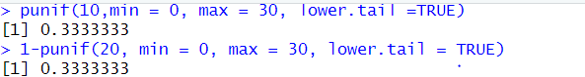

**Question 2**

1. **pexp(3,rate = 0.5,lower.tail = TRUE)**

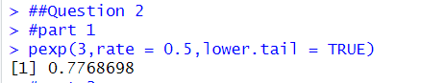

1. **1-pexp(4,rate = 0.5,lower.tail = TRUE)**

**pexp(4,rate=0.5,lower.tail = FALSE)**

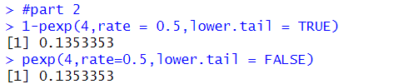

1. **pexp(4,rate=0.5,lower.tail =TRUE)-pexp(2,rate = 0.5,lower.tail=TRUE)**

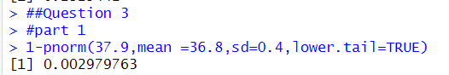

**Question 3**

1. **1-pnorm(37.9,mean =36.8,sd=0.4,lower.tail=TRUE)**



1. **pnorm(36.9,mean=36.8, sd=0.4, lower.tail=TRUE)-pnorm(36.4,mean=36.8,sd=0.4,lower.tail=TRUE)**



1. **qnorm(0.012,mean=36.8,sd=0.4, lower.tail =TRUE)**



1. **qnorm(0.01,mean =36.8,sd = 0.4, lower.tail = FALSE)**

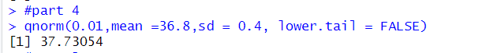

**Exercise**

1. **punif(25, min = 0, max = 40, lower.tail = TRUE) - punif(10, min = 0, max = 40, lower.tail = TRUE)**

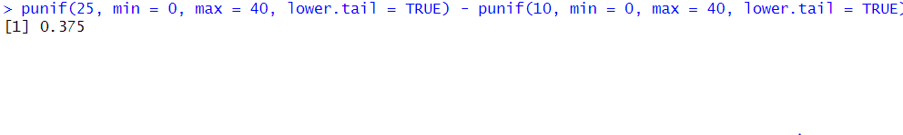

1. **pexp(2, rate = 1/3, lower.tail = TRUE)**

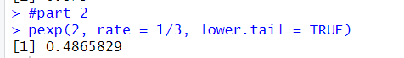

1. **(i)** **1 - pnorm(130, mean = 100, sd = 15, lower.tail = TRUE)**



**(ii) qnorm(0.95, mean =100, sd = 15, lower.tail = TRUE)**

